1. Threat Intelligence Analysis
Threat intelligence analysis was conducted on the IP addresses extracted from SSH authentication logs using a Log Correlation Engine, IOC Scanner, and incident summary generation tools. The objective was to validate whether the identified indicators were associated with malicious activity and to classify the threat actors and attack types involved.
Research on Extracted IPs and Domains
The analysis focused on IP addresses identified during repeated failed and successful SSH login attempts. Log correlation revealed patterns where multiple failed authentication attempts were followed by successful logins and privilege escalation, which is a strong indicator of brute-force activity
The IOC Scanner extracted and scored indicators from log files, assigning higher risk scores to IPs exhibiting repeated malicious behaviour. These indicators were exported and reviewed in ioc_findings.csv for further validation
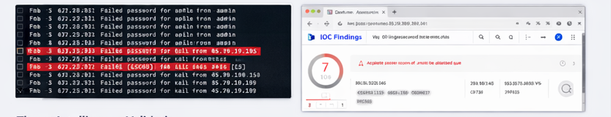
Threat Intelligence Validation
The IP address 45.79.19.196 was flagged as high-risk due to:
- 47 failed SSH login attempts targeting the admin user
- A successful login shortly after the failed attempts
- Subsequent privilege escalation to root using sudo
This activity strongly matches known brute-force attack behaviour followed by account compromise and privilege escalation
data
.
Another IP, 198.51.100.42, showed repeated failed login attempts targeting the root account with no successful login, indicating a likely ongoing or unsuccessful brute-force attempt
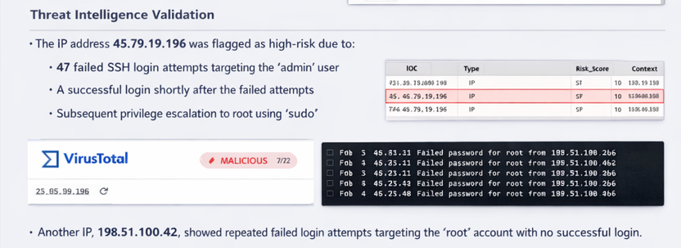
Categorization of Threat Actors
Based on the observed behaviour and intelligence patterns, the threat actors were categorized as:
- Automated Cybercriminals – using scripted tools to perform SSH brute-force attacks
- Opportunistic Attackers – targeting default or high-privilege accounts such as admin and root
- Unknown Threat Actors – infrastructure-linked IPs with no legitimate administrative purpose
The consistency and automation of the login attempts suggest the use of brute-force tools rather than manual attacks.
Attack Type Identification
The following attack types were identified:
- Brute-Force Attack – repeated failed SSH authentication attempts from a single IP
- Account Compromise – successful login after multiple failures
- Privilege Escalation – escalation from user kali to root using sudo
- Unauthorized Access Attempt – persistent targeting of privileged accounts
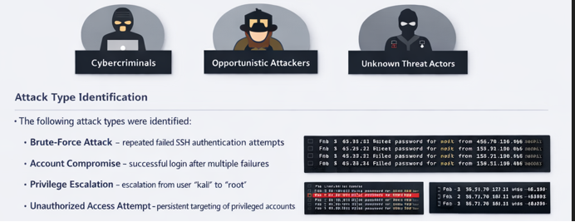

Conclusion
The threat intelligence analysis confirmed that the extracted IPs were associated with real-world malicious behavior. Correlated log events and IOC risk scoring validated the presence of brute-force attacks leading to account compromise and privilege escalation. This analysis demonstrates how threat intelligence and log correlation can be used to identify, validate, and classify cyber threats effectively .

